|  |
| --- |
|  |
| Restrict where this project can be run | | | [Help for feature: Restrict where this project can be run](http://localhost:8080/job/d/configure) |
|  |  | |  |
|  |  |  |  |
|  |  |  |  |

Discard oldbuilds :

1…install discard old build plugin.

Jenkins does not store the builds in the workspace.   
  
When you configure Jenkins to archive build artifacts, they are copied away from the workspace. These artifacts, and build logs and test results are controlled by the Discard Old Builds setting.   
  
If you have old builds in the workspace, you probably have not set up anything to clean the workspace from files from previous builds. You could check the box under SCM settings to clean the workspace before building. (This setting is in the SCM part of the job configuration because every SCM plugin has their own way of doing it.)   
  
There is also a delete workspace plugin, which is useful for builds that do not use SCM.

# Error: no workspace

There's no workspace for this project. Possible reasons are:

1. The project was renamed recently and no build was done under the new name.
2. The agent this project has run on for the last time was removed.
3. The workspace directory (/var/lib/jenkins/workspace/hh) is removed outside Jenkins.
4. The workspace was wiped out and no build has been done since then.

Run a build to have Jenkins create a workspace.

**Basic**

After installing this plugin, a new post-build step named 'Discard Old Builds' appears.

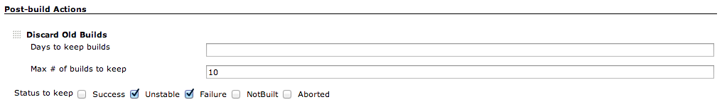

'Days to keep builds' and 'Max # of builds to keep' work as same as Jenkins core function.  
With checking statuses in 'Status to keep' section, Jenkins will keep the builds with selected statuses.

* Last build / last stable build / last successful build are always kept.
* If all the checkboxes are left unchecked, builds with any status are kept.

**Advanced**

In advanced section, you can configure how to treat the builds which are older than the criteria specified in basic configuration.  
For old builds, perhaps you don't want to keep all, but sometimes you want to keep some of them with less frequency.

**Example1**

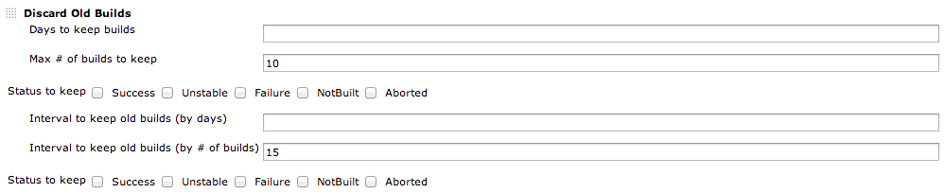

This configuration shows:

* Latest 10 builds are kept.
* Except for the latest 10, one in 15 builds are kept(#1, #16, #31,...).

**Example2**

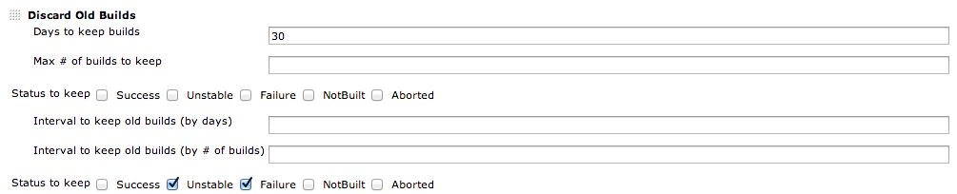

This configuration shows:

* Builds within 30 days are kept.
* For builds older than 30 days, only builds with unstable/failure are kept.